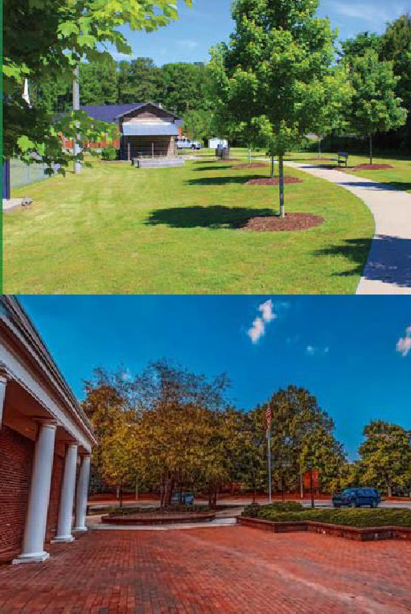
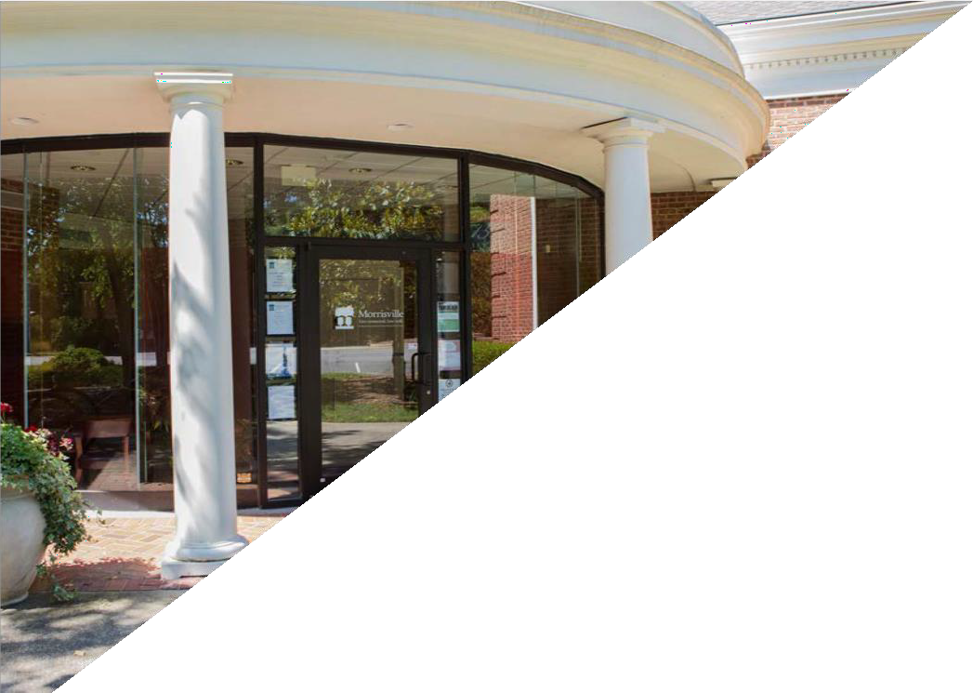
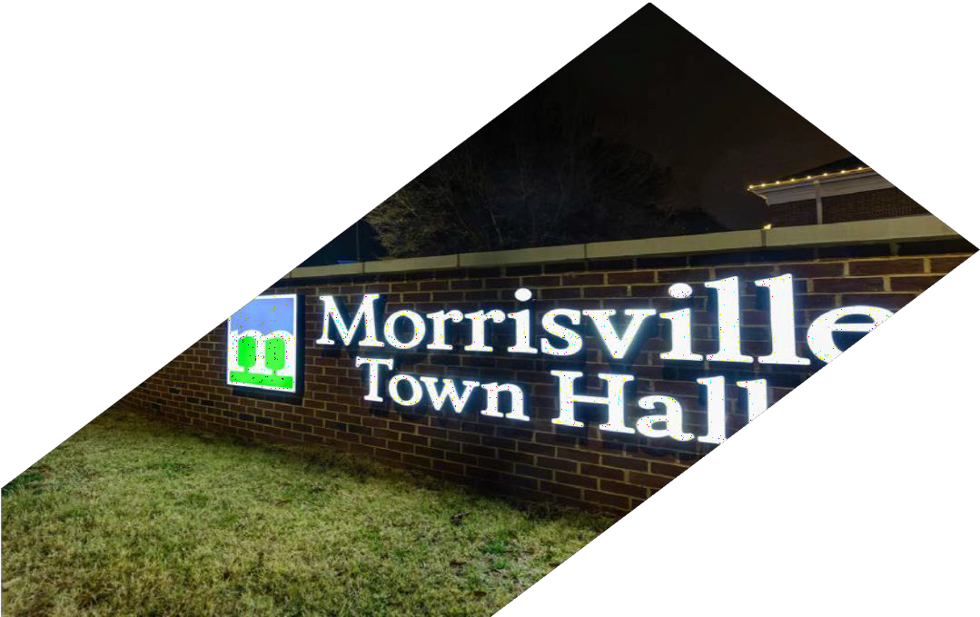
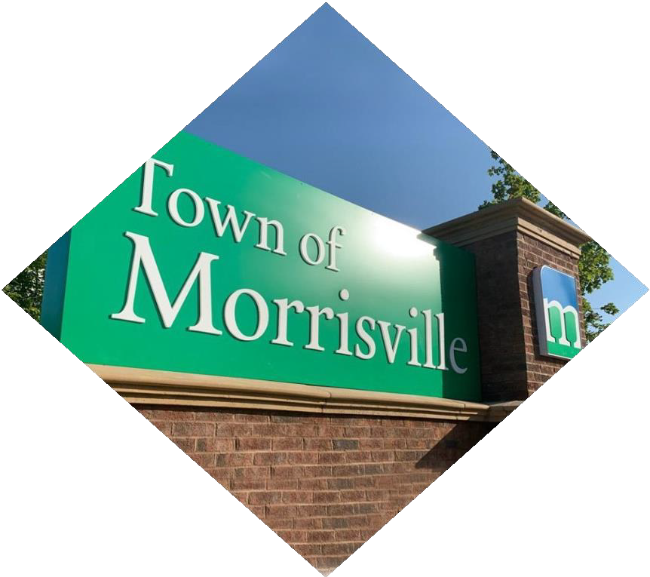
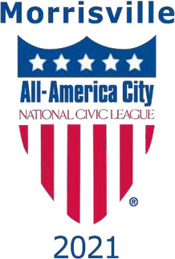
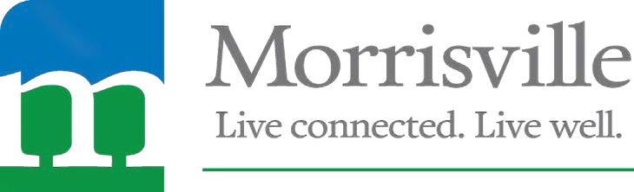
THE TOWN OF MORRISVILLE, N.C.

Public Works Director

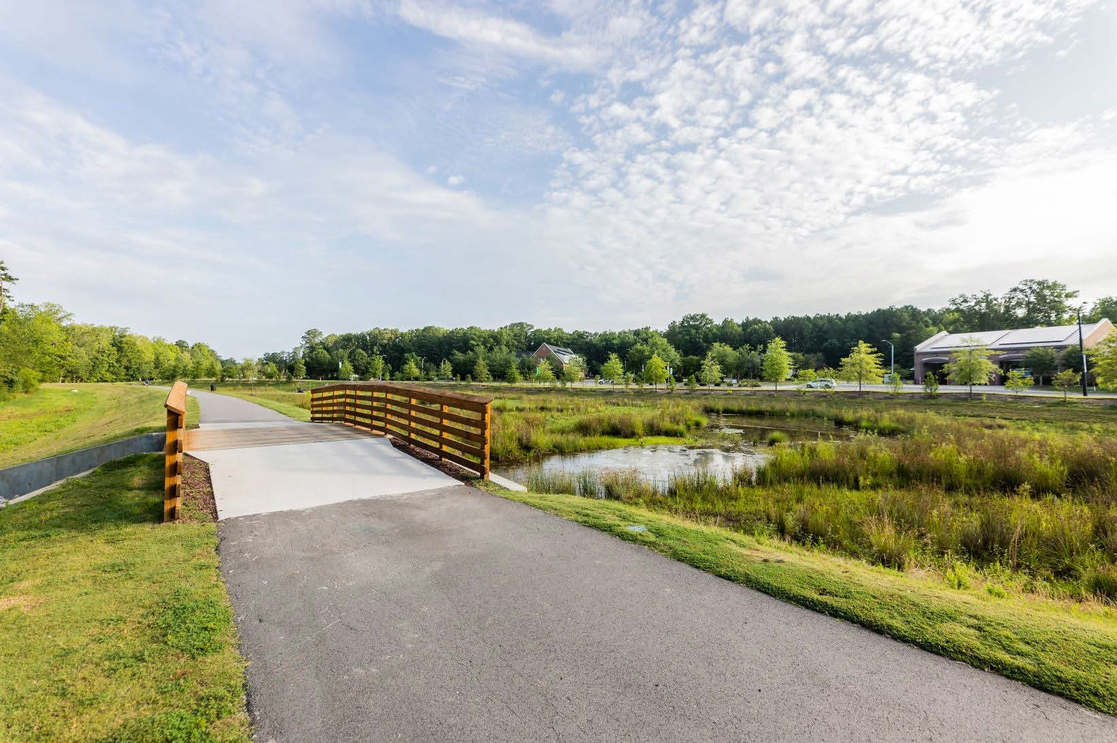
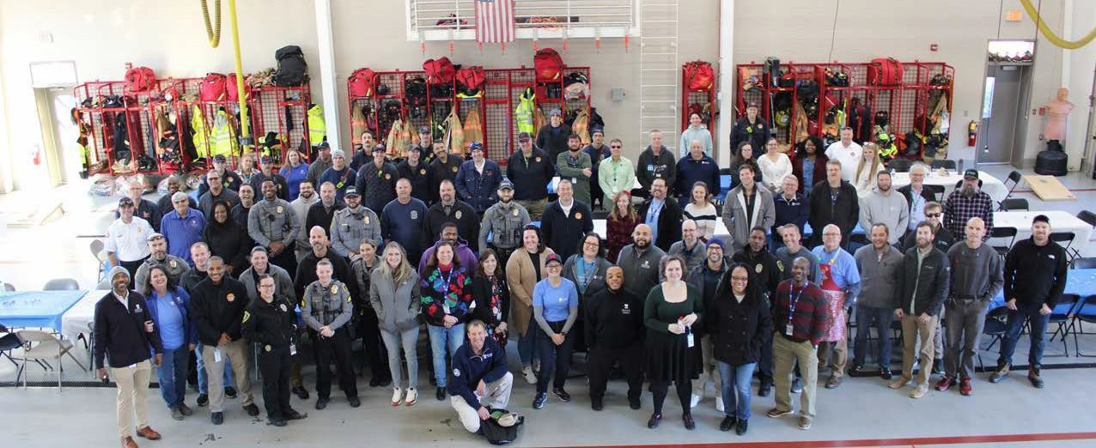
TOWN OF MORRISVILLE

Progressive, Diverse, Established Community Seeks New Director
As one of the fastest growing and most diverse towns in North Carolina, Morrisville offers employees the opportunity to work, live, and thrive in a community devoted to the essential values of dedication, integrity, courtesy, and innovation. The Town of Morrisville is located adjacent to the highly sought-after Research Triangle Park (RTP) area of the Raleigh- Durham metro community. Our proudly diverse community is expected to reach full population growth in the next three to five years at approximately 35,000 residents. In our vibrant community recreation, greenways, sustainability, and well-being are all at the forefront of our planning process. With a median household income nearly double the state average, residents stay in Morrisville because of the superb quality of life. A proud recipient of the 2021 All-America City Award, we invite you to join our team!

The next Public Works Director will be instrumental in the maintenance and upkeep of the Town's portfolio of parks, including the stunning Indian Trail Greenway (pictured left).

About the Organization:
The Public Works Department is made up of six divisions that are responsible for the maintenance, operation, and repair of Town-owned buildings, grounds, parks, athletic fields, recreation areas, fleet vehicles, contracted services, sustainability programs, rights-of-way, and streets.
The Team’s 25 employees are responsible for maintaining the infrastructure and amenities that make Morrisville run sustainably, safely, and efficiently. Whether it’s the upkeep of the Town’s composting initiatives, repairing roads, or maintaining the park grounds, the Public Works Department is there to help.
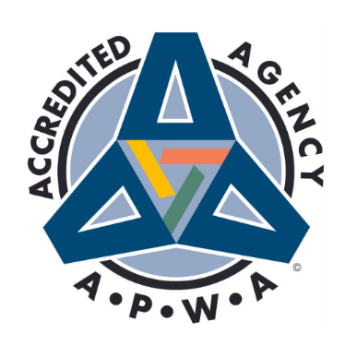
A few of the things our team maintains week-in and week-out:
- 55 miles of streets
- 120 vehicles and equipment
- 114,991 square feet of buildings
- 7 parks
- 13 athletic fields
- 6 playgrounds
The Morrisville Public Works Department is an Accredited Agency through the American Public Works Association (APWA).
- 3 recreation centers
- 10.6 miles of greenways
- 19 rights-of-way
- Grounds at all Town Facilities

Our Focus:
The strategic focus of Morrisville is guided by the community vision established in the 2017 Connect Morrisville Strategic Plan and renewed in the 2025 update. A 2022 Community Survey indicates that 94% of residents think Morrisville is a good or excellent place to live. The Town also relies on its Comprehensive Transportation Plan, Land Use Plan, Capital Investment Program, and other policies adopted by the Town Council to guide its work.

Our Goals:

- Sustainable, Livable Community Growth
- Public Safety Readiness
- Engaged, Inclusive Community
- Community Mobility
- Economic Prosperity
- Operational Excellence
- Organizational Resiliency

About the Position:
The Town is seeking an experienced and visionary leader to serve as its next Public Works Director. This position is responsible for overseeing a wide range of essential services that keep the community running, including fleet and facility maintenance, streets and grounds maintenance, parks and athletic facilities, sustainability initiatives, and special projects. As a member of the Town Manager’s leadership team, the Director plays a vital role in aligning departmental operations with the Town’s strategic goals while ensuring high-quality, cost-effective service delivery.

The ideal candidate will bring a strong background in municipal public works management, with proven expertise in budgeting, strategic planning, and contract administration. They will lead a talented team of supervisors and staff, fostering collaboration, accountability, and innovation across all divisions. With significant community engagement responsibilities, the Director will serve as a key point of contact for residents, contractors, and regional partners, providing technical expertise, clear communication, and responsive service.

This is a unique opportunity for a results-oriented professional who thrives on both operational excellence and long-term planning. The successful candidate will demonstrate strong leadership, superior problem- solving skills, and the ability to adapt to dynamic challenges—from capital projects and sustainability initiatives to emergency response and storm recovery.

About the Morrisville Team:
The Morrisville Team is led by Town Manager Brandon Zuidema, who is supported by the Senior Leadership Team consisting of Deputy Town Manager Giselle Rodriguez, Assistant Town Manager John Letteney, and Director of Management Services Jeanne Hooks. The Leadership Team consists of our Senior Leadership, our twelve Department Heads, and the Town Clerk. Our Leadership Team Mission Statement is,

“Morrisville’s Leadership Team empowers our employees and stakeholders by fostering a culture of collaboration, transparency, mutual accountability, and innovation
to create positive outcomes in the organization and the community.”

- We value the contributions of all members of our Team; we are only successful if everyone is consistently performing in their role. No single member of our Team is more important than any other; we need all team members collaborating to get the mission accomplished. We look forward to our new Public Works Director stepping in and helping our Team to enhance our work and outcomes.
- Our Team is committed to our core values of Dedication, Integrity, Courtesy, and Innovation. We are most successful when these values drive our decision-making, our actions, and our collaborative efforts.
- A good day in Morrisville is when we can make a positive difference in our community! Our new Director will have the opportunity to support “make a difference days” for our residents and visitors.

Qualifications:
The successful Public Works Candidate will have a Bachelor's Degree in Civil Engineering, Public Administration, Construction Management, Business Administration, or a related field, with a Master's Degree preferred. Ideally, the candidate will also have their Professional Engineering License.

The Successful Candidate:

  - Lead with vision, aligning departmental priorities with the Town’s strategic goals.

  - Inspire staff and foster a high-performing culture through support, accountability, and clear direction.

  - Think strategically, developing both mid- and long-range plans to meet current and future needs.

  - Organize, direct, and coordinate the work of multiple divisions with efficiency and clarity.

  - Drive strategic planning initiatives related to accreditation, budgeting, and long-term infrastructure goals.

  - Establish clear goals and performance standards while monitoring progress and outcomes.

  - Oversee service contracts with a focus on cost-effectiveness, quality, and accountability.

  - Anticipate future infrastructure and equipment needs and recommend practical solutions.

  - Manage resources and maintain adequate inventories to ensure reliable service delivery.

  - Research, evaluate, and implement innovative practices to improve public works operations.

  - Model effective supervision, performance evaluation, and personnel management.

  - Prepare and manage departmental budgets with financial accountability and transparency.

  - Lead capital planning efforts, supporting investment in infrastructure and long-term sustainability.

  - Oversee street maintenance and safety, including pavement management and traffic calming strategies.

  - Provide technical expertise and advice in meetings with committees, boards, and elected officials.

  - Build strong relationships with residents, businesses, and developers by responding to concerns with professionalism and care.

  - Collaborate with local, regional, and state partners to coordinate projects and services.

  - Demonstrate flexibility by working outside normal hours and leading emergency or on-call responses.

  - Direct emergency response operations, especially during adverse weather and critical incidents.

  - Champion workplace safety and ensure compliance with state and federal standards.

  - Approach challenges with problem-solving skills, adaptability, and a commitment to continuous improvement.

About the Community:

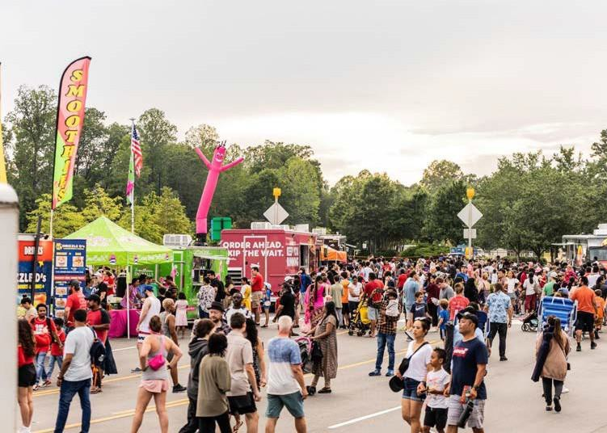
Morrisville is a community of 10 square miles with an estimated 32,000 residents. We are incredibly diverse with demographics of 46% Asian, 35% White, 10% African American, and 9% other backgrounds. The Town and the community are committed to diversity and inclusion for all residents, businesses, and visitors. The Town maintains a focus on cultural awareness and celebrating the cultural diversity of our community.
“Live Connected. Live Well.” is the Town’s philosophy. When surveyed, residents communicated they value the connection they feel when in the Town - the connection they have to global businesses, opportunities, parks, and open space, and most importantly, to each other. Morrisville is a place to gather together, talk with neighbors, and engage with Town leaders.

Morrisville is a warm and welcoming community that embraces small-town ideals with the conveniences and amenities of a metropolitan city available in Town or within easy access nearby.

Morrisville Accolades
Live Connected. Live Well.
Morrisville is one of the fastest
growing and most diverse towns in North Carolina. Recognized as an All-America City by the National Civic League in June 2021, Morris- ville was one of only 10 communities nationwide to earn this recognition. Morrisville’s many accolades include the following:

- No. 1 Best Place to Live in North Carolina by Niche
(2021/2022)
- No. 3 Best Place to Live in the United States by Money Magazine (2020)
- No. 10 Best Small City in the U.S. to Start a Business by WalletHub (2023)
- No. 3 Best Place to Raise a Family in North Carolina by WalletHub
(2019)
- No. 5 Best Place to Live for Families by Fortune Well, a subsidiary of Fortune.com
(2022)

Morrisville is adjacent to North Carolina’s Research Triangle Park – a national hotbed of technological development, hosting over 250 companies and 50,000 workers. The Town has a diverse economic base including global companies, headquarters, start-ups, technology industries, and emerging biomanufacturing and life sciences clusters. The Town has immediate access to highways 40, 85, and 540 and is conveniently located to both Raleigh and Durham for access to city amenities such as the Raleigh Durham International Airport, just 10 minutes from Morrisville.

The Town’s population demographics are diverse, affluent, and highly educated. As a result, the local median household income is now $114,075, nearly twice the state average!

People stay in Morrisville because of the superb quality of life, regional proximity, and cultural enrichment. The Wake County Public School System offers excellent educational opportunities to Morrisville families, including the recent addition of the Wake Early College of Information and Biotechnologies on the Wake Technical Community College campus in Morrisville and Morrisville High School, which is anticipated to open for the 2027-2028 school year. Wake Technical Community College also offers traditional college courses at their campus.




Cultural enrichment, through events like the Town’s annual Diwali Festival, is one of the reasons community members love living, working, and playing in Morrisville!

Salary and Benefits:
The Town of Morrisville is recognized as a high-quality employer that values and supports its employees. Information about the Town’s generous benefits (including but not limited to flexible work schedules – including up to two days of remote work per week following an orientation period, paid time off (PTO) beyond other paid leave, and contributions to a 401K) can be found here. As a condition of employment for all positions with the Town of Morrisville, the selected candidate must successfully complete a pre-employment background check, drug screening, and motor vehicle record check.

To apply, please visit The Town of Morrisville Careers Page and click on
Public Works Director

- All applications must be submitted Online via the Town's Careers Page.
- Resumes and cover letters must be uploaded with the application.
- Applications will be reviewed on a rolling basis until the position is filled. However, priority review will be granted to those that apply by September 29th.
- Successful semi-finalists will be invited to participate in virtual interviews and skill evaluation exercises.
- Interviews with members of the leadership team will follow quickly at a subsequent time in person.
- For any questions or confidential inquiry, please contact Josh England by emailing jengland@morrisvillenc.gov

The Town of Morrisville, NC is an Equal Opportunity Employer
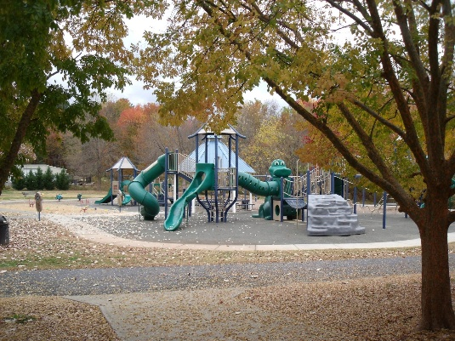
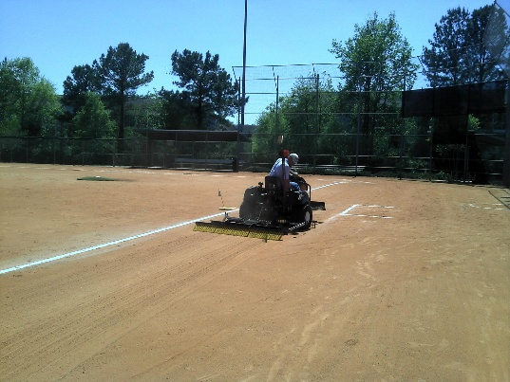
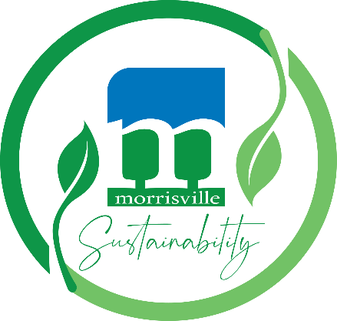

The Public Works team aims to provide exceptional service through its sustainability programs and upkeep of public amenities.

The talent acquisition goal of the Town of Morrisville is to secure and retain the most suitable applicant for each vacant position.
The Town of Morrisville recruits, hires, employs, trains, promotes, and compensates individuals based on job-related qualifications and abilities. Our Town has a longstanding policy of providing a work environment that respects the dignity and worth of each individual and is free from all forms of employment discrimination, including harassment, because of race, natural hair or hairstyles, ethnicity, creed, color, religious belief or non-belief, sex, pregnancy, sexual orientation, gender identity or expression, marital or familial status, national origin or ancestry, National Guard or veteran status, political affiliation, age, disability, genetic information, or other protected characteristics protected by law.

The Town of Morrisville also provides reasonable accommodation to qualified individuals with disabilities or as a result of other needs protected by law. If you need to inquire about an accommodation or need assistance with completing the application process, please email HR@MorrisvilleNC.gov

