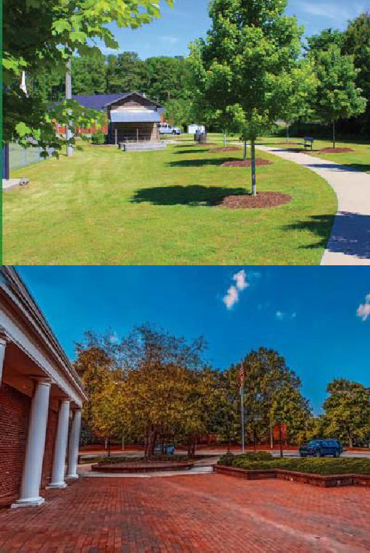
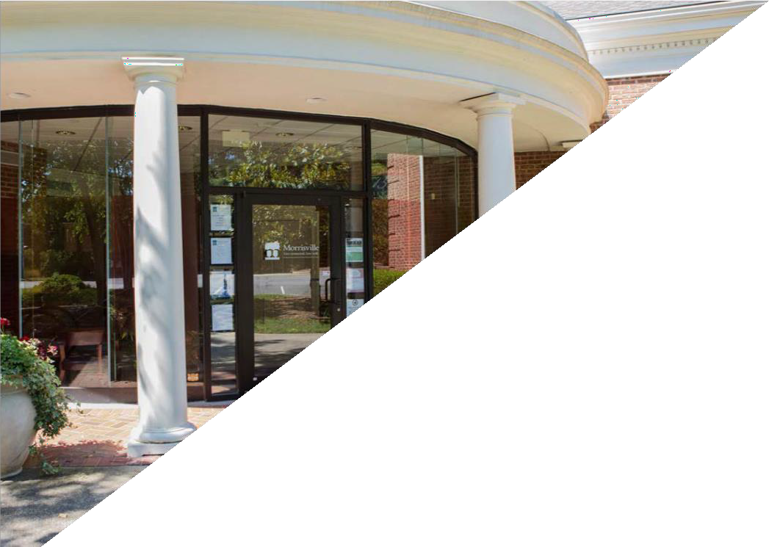
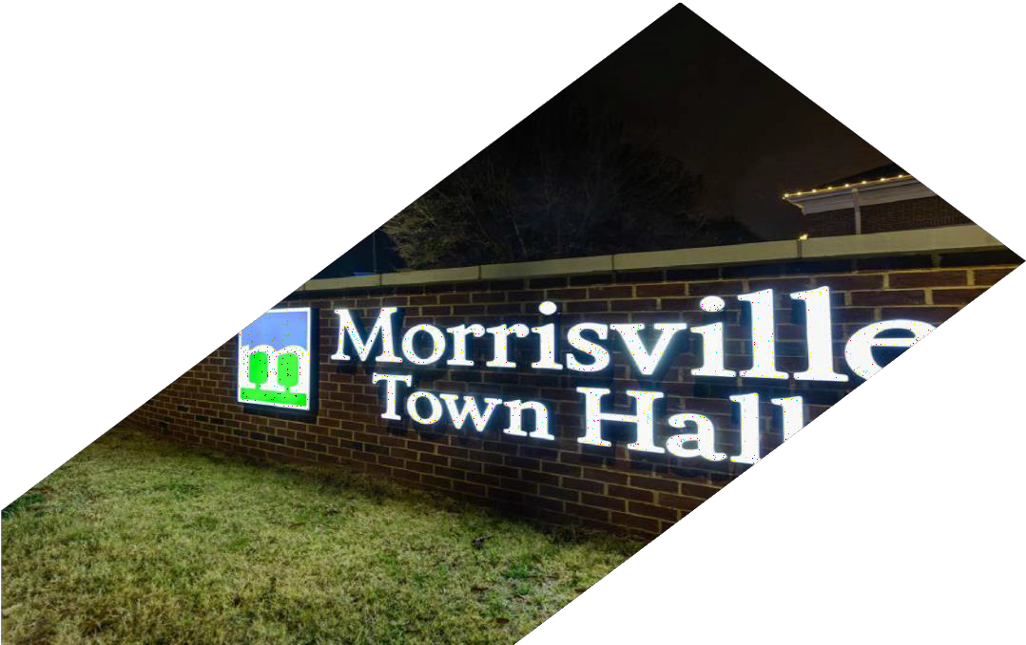
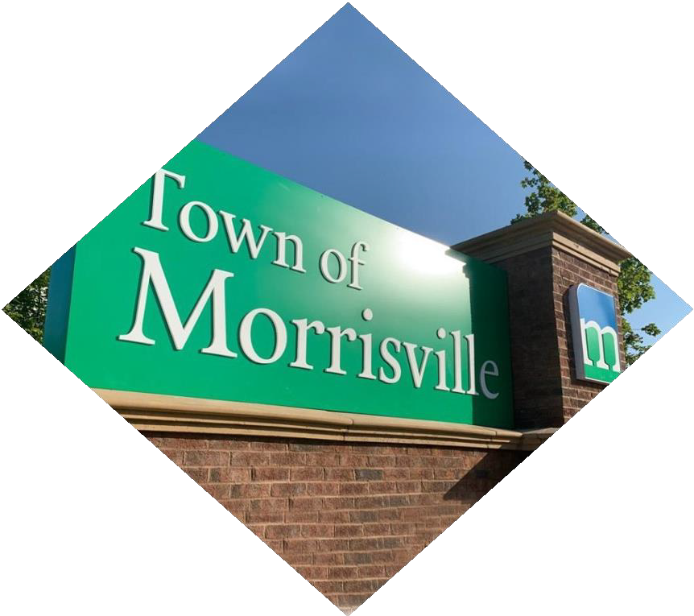
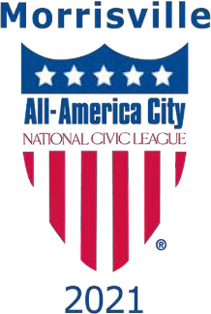
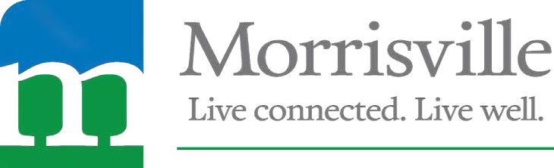
THE TOWN OF MORRISVILLE, N.C.

Parks, Recreation and Cultural Resources Director

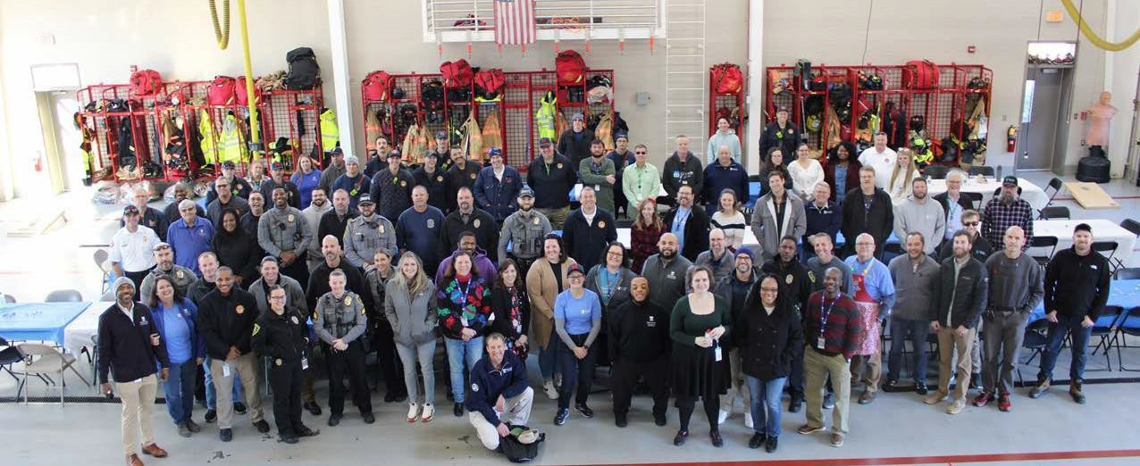

TOWN OF MORRISVILLE

Progressive, Diverse, Established Community Seeks New Director
As one of the fastest growing and most diverse towns in North Carolina, Morrisville offers employees the opportunity to work, live, and thrive in a community devoted to the essential values of dedication, integrity, courtesy, and innovation. The Town of Morrisville is located adjacent to the highly sought-after Research Triangle Park (RTP) area of the Raleigh- Durham metro community. Our proudly diverse community is expected to reach full population growth in the next three to five years at approximately 35,000 residents. In our vibrant community recreation, greenways, sustainability, and well-being are all at the forefront of our planning process. With a median household income nearly double the state average, residents stay in Morrisville because of the superb quality of life. A proud recipient of the 2021 All-America City Award, we invite you to join our team!

The next Parks, Recreation and Cultural Resources Director will lead an amazing team responsible for innovative aquatics, athletics, fitness, recreation, special event, senior, and youth programming. The Director will be involved in expanding out cricket efforts, implementing a new Master Plan, and supporting a diverse community with seven parks, miles of greenways, and three facilities

About the Organization:
The Town of Morrisville Parks, Recreation & Cultural Resources Department is accredited by the National Commission for Accreditation of Park and Recreation Agencies (CAPRA), which sets standards and recognizes parks and recreational agencies that meet best practices for quality assurance and improvement.
Our team’s mission is to help Morrisville become the Triangle’s standard for livable communities by:
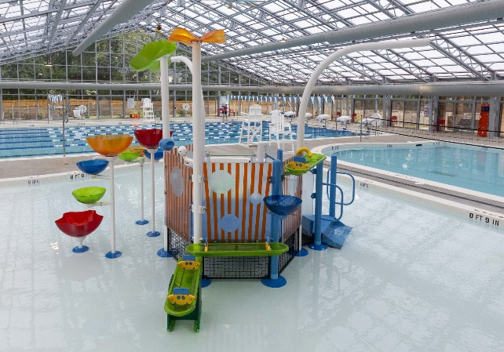
- Creating advocates by engaging the community in an ongoing conversation about benefits and values of parks and recreation.
- Responding to change with creativity, technology and innovation.
- Taking purposeful steps in the pursuit of quality parks, recreation facilities and programs.
Morrisville is home to several state-of-the-art recreational facilities, such as the Morrisville Aquatics & Fitness Center. Amenities include two indoor racquetball courts, a full-size indoor pool, outdoor tennis courts, and a range of fitness equipment.

It’s our team’s goal to enrich the Morrisville community by creating quality recreation experiences, celebrating our local culture and enhancing our natural resources. A goal which is deeply embedded in our Town’s motto and ethos:
“Live Connected, Live Well”

Our Focus:
The strategic focus of Morrisville is guided by the community vision established in the 2017 Connect Morrisville Strategic Plan and renewed in the 2025 update. A 2022 Community Survey indicates that 94% of residents think Morrisville is a good or excellent place to live. The Town also relies on its Parks, Recreation, and Cultural Resources Master Plan (currently being updated), Comprehensive Transportation Plan, Land Use Plan, Capital Investment Program, and other policies adopted by the Town Council to guide its work.

Our Goals:

- Sustainable, Livable Community Growth
- Public Safety Readiness
- Engaged, Inclusive Community
- Community Mobility
- Economic Prosperity
- Operational Excellence
- Organizational Resiliency

About the Position:
Reporting directly to the Assistant Town Manager, the Parks, Recreation and Cultural Resources Director performs complex professional and administrative work leading the Town’s parks, recreation, and cultural resources programs. As a member of the Town Manager’s leadership team, this role requires collaboration, creativity, innovation, and sound decision-making. The Director provides strategic vision to ensure the sustainability of existing services while planning for future growth.

This position oversees a wide range of operations including community centers, senior services, youth programs, aquatics and fitness, athletics, special events, cultural activities, parks, greenways, and facilities. The Director manages staff, supervises daily operations, and ensures the department meets the needs of residents through high-quality programs and facilities. The role also involves significant public engagement and collaboration with other Town departments, advisory committees, community partners, and regional governments.

The ideal candidate will bring extensive experience leading parks, recreation, and cultural programs, with the ability to balance operational excellence, business acumen, and strategic vision. They will be an exceptional communicator and relationship-builder, capable of fostering partnerships and engaging effectively with diverse stakeholders. This is an exciting opportunity for a forward-thinking leader to shape vibrant, sustainable, and innovative recreational and cultural experiences for the community.

About the Morrisville Team:
The Morrisville Team is led by Town Manager Brandon Zuidema, who is supported by the Senior Leadership Team consisting of Deputy Town Manager Giselle Rodriguez, Assistant Town Manager John Letteney, and Director of Management Services Jeanne Hooks. The Leadership Team consists of our Senior Leadership, our twelve Department Heads, and the Town Clerk. Our Leadership Team Mission Statement is,
“Morrisville’s Leadership Team empowers our employees and stakeholders by fostering a culture of collaboration, transparency, mutual accountability, and innovation
to create positive outcomes in the organization and the community.”
- We value the contributions of all members of our Team; we are only successful if everyone is consistently performing in their role. No single member of our Team is more important than any other; we need all team members collaborating to get the mission accomplished. We look forward to our new Director stepping in and helping our Team to enhance our work and outcomes.
- Our Team is committed to our core values of Dedication, Integrity, Courtesy, and Innovation. We are most successful when these values drive our decision-making, our actions, and our collaborative efforts.
- A good day in Morrisville is when we can make a positive difference in our community! Our new PRCR Director will have the opportunity to support “make a difference days” for our residents and visitors.
Qualifications:
The successful Parks, Recreation and Cultural Resources candidate will have a bachelor’s degree in Parks/Recreation Management, Business Administration, or a related field, and be a Certified Parks and Recreation Professional (CPRP). The preferred candidate will have a master’s degree in a Parks or Management discipline and Certified Parks and Recreation Executive (CPRE) credential.
The Successful Candidate

  - Leads by example, supporting department staff through effective communication, mentoring, training, succession planning, and visioning.

  - Supervises the Assistant Parks Director, Special Events Division, and other professional staff.

  - Is able to synthesize and derive clear and attainable workplace goals and objectives from the Town Strategic Plan, the department strategic plan, and the department Master Plan.

  - Develops, secures and administers service contracts, including but not limited to rentals, use agreements, teaching agreements.

  - Plans, organizes, promotes, and directs comprehensive, town-wide athletic, parks, recreation, greenway and cultural resources programs.

  - Serves as a member of the Town Manager’s leadership team.

  - Proactively seeks out community partners, manages key stakeholders, and represents the department at public meetings, board meetings, civic group meetings and with other agencies.

  - Provides visioning and guidance to the programs offered at the community centers.

  - Prepares and manages the department’s budget; oversees department expenditures.

  - Collaborates with other Town staff to develop the department’s Capital Improvement Program.

  - Oversees the operations at community centers with diverse program offerings.

  - Oversees the department’s accreditation compliance.

  - Serves as a member of the Town’s cricket oversight team.

  - Collaborates with other Town departments for the planning, design, and acquisition of future parks and recreation facilities, greenways and open space.

  - Directs the planning of departmental special events.

  - Evaluates the job performance of direct reports; reviews evaluations conducted by subordinate supervisors and ensures compliance with personnel policies and management of personnel issues.

  - Receives and responds to resident and stakeholder inquiries and complaints.

  - Administers and writes grant proposals.

  - Actively plans, assesses and maintains data to support cost recovery goals.

About the Community:

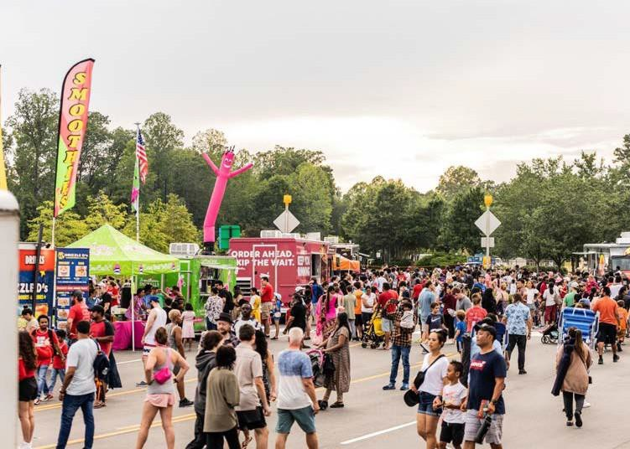
Morrisville is a community of 10 square miles with an estimated 32,000 residents. We are incredibly diverse with demographics of 46% Asian, 35% White, 10% African American, and 9% other backgrounds. The Town and the community are committed to diversity and inclusion for all residents, businesses, and visitors. The Town maintains a focus on cultural awareness and celebrating the cultural diversity of our community.
“Live Connected. Live Well.” is the Town’s philosophy. When surveyed, residents communicated they value the connection they feel when in the Town - the connection they have to global businesses, opportunities, parks, and open space, and most importantly, to each other. Morrisville is a place to gather together, talk with neighbors, and engage with Town leaders.

Morrisville is a warm and welcoming community that embraces small-town ideals with the conveniences and amenities of a metropolitan city available in Town or within easy access nearby.

Morrisville Accolades
Live Connected. Live Well.
Morrisville is one of the fastest
growing and most diverse towns in North Carolina. Recognized as an All-America City by the National Civic League in June 2021, Morris- ville was one of only 10 communities nationwide to earn this recognition. Morrisville’s many accolades include the following:

- No. 1 Best Place to Live in North Carolina by Niche
(2021/2022)
- No. 3 Best Place to Live in the United States by Money Magazine (2020)
- No. 10 Best Small City in the U.S. to Start a Business by WalletHub (2023)
- No. 3 Best Place to Raise a Family in North Carolina by WalletHub
(2019)
- No. 5 Best Place to Live for Families by Fortune Well, a subsidiary of Fortune.com
(2022)

Morrisville is adjacent to North Carolina’s Research Triangle Park – a national hotbed of technological development, hosting over 250 companies and 50,000 workers. The Town has a diverse economic base including global companies, headquarters, start-ups, technology industries, and emerging biomanufacturing and life sciences clusters. The Town has immediate access to Highways 40, 85, and 540 and is conveniently located to both Raleigh and Durham for access to city amenities such as the Raleigh Durham International Airport, just 10 minutes from Morrisville.
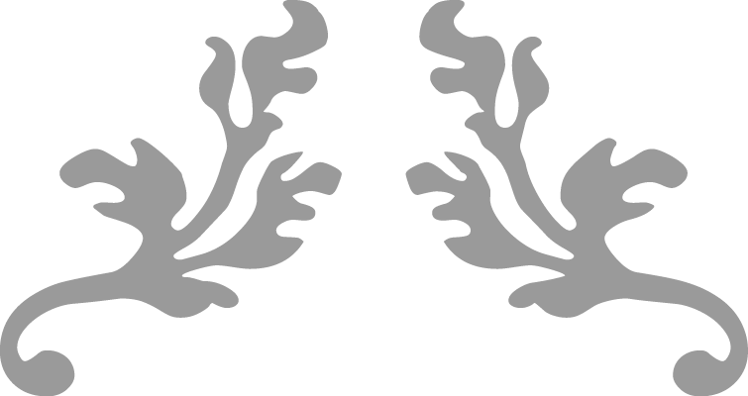
The Town’s population demographics are diverse, affluent, and highly educated. As a result, the local median household income is now $125,404, nearly twice the state average!



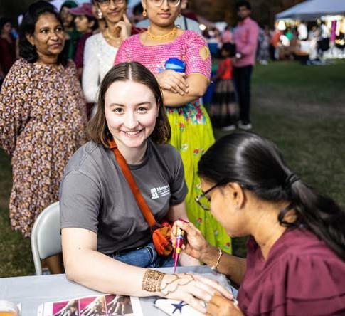
People stay in Morrisville because of the superb quality of life, regional proximity, and cultural enrichment. The Wake County Public School System offers excellent educational opportunities to Morrisville families, including the recent addition of the Wake Early College of Information and Biotechnologies on the Wake Technical Community College campus in Morrisville and Morrisville High School, which is anticipated to open for the 2027-2028 school year. Wake Technical Community College also offers traditional college courses at their campus.
Cultural enrichment, through events like the Town’s annual Diwali Festival, is one of the reasons community members love living, working, and playing in Morrisville!

Salary and Benefits:
The Town of Morrisville is recognized as a high-quality employer that values and supports its employees. Information about the Town’s generous benefits (including but not limited to flexible work schedules – including up to two days of remote work per week following an orientation period, paid time off (PTO) beyond other paid leave, and contributions to a 401K) can be found here. As a condition of employment for all positions with the Town of Morrisville, the selected candidate must successfully complete a pre-employment background check, drug screening, and motor vehicle record check.

To apply, please visit The Town of Morrisville Careers Page and click on
Parks, Recreation, and Cultural Resources Director

- All applications must be submitted Online via the Town's Careers Page.
- Resumes and cover letters must be uploaded with the application.
- Applications will be reviewed on a rolling basis until the position is filled. However, priority review will be granted to applications received by September 29th.
- Successful semi-finalists will be invited to participate in virtual interviews and skill evaluation exercises.
- Interviews with members of the leadership team will follow quickly at a subsequent time in person.
- For any questions or confidential inquiry, please contact Josh England by emailing jengland@morrisvillenc.gov

The Town of Morrisville, NC is an Equal Opportunity Employer

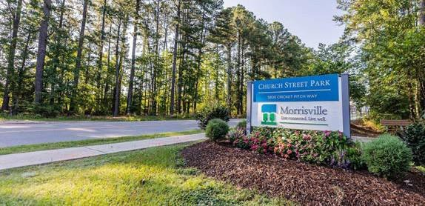
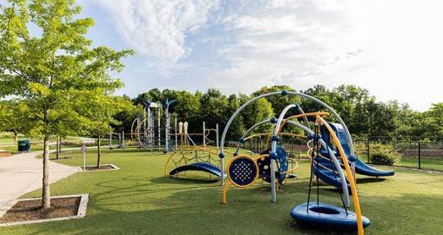
The Town of Morrisville offers great recreation programs, activities, and events for everyone in the family, all year long.

The talent acquisition goal of the Town of Morrisville is to secure and retain the most suitable applicant for each vacant position.
The Town of Morrisville recruits, hires, employs, trains, promotes, and compensates individuals based on job-related qualifications and abilities. Our Town has a longstanding policy of providing a work environment that respects the dignity and worth of each individual and is free from all forms of employment discrimination, including harassment, because of race, natural hair or hairstyles, ethnicity, creed, color, religious belief or non-belief, sex, pregnancy, sexual orientation, gender identity or expression, marital or familial status, national origin or ancestry, National Guard or veteran status, political affiliation, age, disability, genetic information, or other protected characteristics protected by law.

The Town of Morrisville also provides reasonable accommodation to qualified individuals with disabilities or as a result of other needs protected by law. If you need to inquire about an accommodation or need assistance with completing the application process, please email HR@MorrisvilleNC.gov

